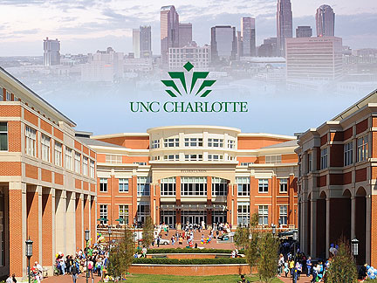 |  | - University Writing 1102  - Feasibility Study

Academic success is the common goal for many students, parents, teachers, and institutions. This study has been created to take a closer look at what still can be done to assist students, and what is already being done to aid academic success for freshman students enrolled at UNC Charlotte.

Many college students arrive on campus unprepared to succeed in college, not because the course material is above the students’ capacity, but simply due to lack of organizational skills. Helping students address these non-academic deficiencies is vital to the overall academic success of the student (Rutschow).

Currently UNC Charlotte has an 82.4% first year undergraduate retention rate. This means that 17.6% of Charlotte’s undergraduate class has either dropped out or transferred (University of North Carolina at Charlotte College). Some may argue that this is a good number. However, this indicates a portion of the students’ still need help and guidance.
Academic success courses address issues such as study skills, goal setting, and career path help. These are courses that teach students how to write effective notes, take tests, and manage their time. This intern services students to explore their learning styles, and encourages students to develop plans for their college careers and their business careers.
Student Voices

Semesters Wasted: The College Struggle
By: Ruben Arguello
To further see why students struggle during their first semester, I went right to the ones most affected; the students themselves. I personally interviewed two current freshman students enrolled at UNC Charlotte, as well as two sophomore students enrolled at UNC Charlotte. All four students answered seven questions regarding their first semester experience and what they have most struggled with.
”First semester is not difficult because of the work load nor the actual content, however managing stress and organization is the key to a successful first semester” (Croy).
The statement above by Miss Croy is not shocking and was validated by Mr. Lewis in my interview with him. Mr. Lewis is currently enrolled at the university to complete his PHD and is also employed by the university as an academic advisor.
“The courses are meant to challenge all our students but not to fail them. All of us are enrolled here because the university saw that we could succeed” (Lewis).
Still the question remains. Why do students continue to have stressful first semesters?
Who’s to blame?
Could the students be at fault? I was surprised to learn that all the students knew not only where and when to get help, but only one of the students actually utilized the extra resources provided by the university. Looking back I myself only attended two academic success seminars, and only because it was an assignment for my Introduction to Business course.

This information alone troubled me so when time came to interview Mr. Lewis, I got his personal opinion on why students fail to take advantage of the resources that are provided.
“Many students don’t realize when they’re drowning and when they finally do its usually far too late into the semester” (Lewis).
Correlations
Throughout my interviews I noticed the correlation between all four college students. A need to better understand how to continuously be organized was present in all four interviews. One sophomore student verbalized that managing stress was a big factor in her unsuccessful first semester as well. Beth Dumbauld, the editor of straighterline.com; an educational institution for online college students, recently wrote an article on what she found to be eight different student areas that ultimately lead to a successful and healthy academic career.

- Set Priorities
- Be Healthy
- Set Goals
- Be Flexible
- Compromise

While reviewing my intervies I realized that these five success skill sets where mentioned by all of the intervewsees as stressors and obstacles that they all face durring their first semester in college. I have decided to futher analize how all these skills are linked together and how organization is a key solution to a successful accademic career.

Priorities:
Procrastinating on an assignment is one thing, being able to prioritize your time to utilize it to your advantage is completely different. Certain assignments are more important then others and some are more time consuming. The key is to figure out how to deletgate yourself and your resources. Organizing your time is the only way any student can successfully manage their daily lives.

Goals:
Goals are no longer just for soccer players. Students that unaware of their paths are most prone to be unmotivated (Lewis). Many students that unaware of what they want to do are the students that struggle the most, a student must be able to organize their thoughts and set a path that they want to follow,
“Students that are aware of their goals are the students that have been most successful throught their college careers” (Lewis).

Health and Welness:
Many believe students are too lackadaisical and forget the amount of stress that is a part of a students’ daily life. Students themselves are also prone to lack self care. Students must be aware that mental and physical health has a huge impact on their academic success. They must play an active role in their own wellbeing.

Flexibility:
Here is an area where many lack skill in. A student must be able to have a set schedulle that the follow regulary; however, they must also be able to think ahead and be prepared for life’s unfortunate events. To this point must be able to continuously stay organized and ahead of their own lives. This however is not the case and many fail to acount for the unexpected.

Compromise:
“There will always be another party”, I have learned this lesson the hard way. I wanted to be apart of all the party moments, and believed there where no consequencess. My first semester I almost failed and that was my personal wake up call.This is what I let any incoming and currrent students know.College has many way for students to unwind and let loose; never the less, students must be able to stay balanced and learn to compromise their time. If students are able to utilize their time correctly many should be able to have time for themseves and to enjoy the whole collegiate experience.

Students may not struggle with all the success tools that are needed to succeed; however, reinforcing how to stay organized and set these habbits from the beging of the semester can have a significanty positive effect on academic success (My Interventions).

College Success Courses:

College success courses have increased in popularity since 2004 (My Interventins). These courses have been most popular in community colleges, and are very divers in content. Depending on demographics, topics may change but the essentials are always present (My Interventions).

Florida Case Study
Dr. Patricia Windham and her team from the Florida Department of Education studied the results of students who completed student success courses; known as “student life skills,” or “SLS,” with those of students who did not take any student success courses. Dr. Windham and the team understood that SLS course completers were more likely to achieve academic success then the students who did not take SLS courses (Armstrong). In Figure 1 you will see the data collected by the team. Many of the colleges under the Florida Department of Education have made SLS courses optional, some require only certain students to take an SLS course, while other colleges have decided that only students on academic probation are to take the course. One college actually requires all students, whether they need remediation or not, to take an SLS course (Armstrong).
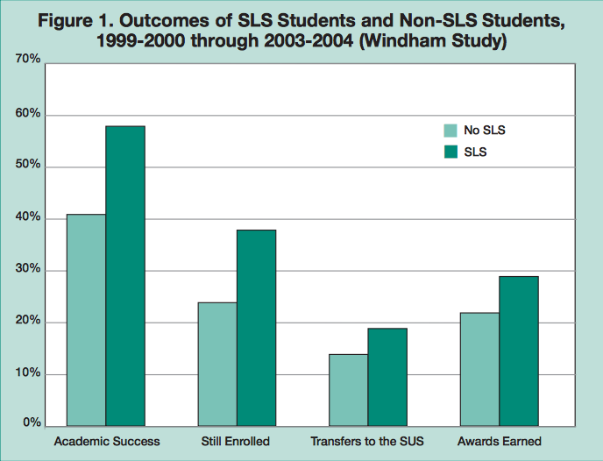
Consequences
For many universities it can be easy to have a reactive mindset to the solution. Many institutions either do not require success course at all, or they make it mandatory once a student is already on academic probation. Specifically, at the University of North Carolina at Charlotte a full time student can loose up to about five hundred dollars per class. And this is just the monetary consequence students face with a rough semester, from there on also comes a lack of motivation, difficulties with grade point averages and time loss (Lewis).

Solution
This study has valuable information on the amount of influence a simple success course can have on students. This simple study is what I am arguing for. The answer to what the problem is and how to fix the issue is in this one study alone. We all hear the same problems that most students encounter, and there is a plethora of solutions; however, a simple course can take care of most of the stressors and give the students the tools they need to succeed. These courses have the effective layout that any institution can customize to best develop their students in a way that can almost guarantee a significant outcome in academic success, student progression, and student retention.

Alternatives
UNC Charlotte has developed an alternative solution; Success Seminars, these seminars are like a success course however they only focus on one topic at a time. Essentially it does the same job, still there is a major flaw, these seminars are not mandatory and many students do not attend. I even evaluated a group of 20 different students around campus on if they have ever attended these seminars. I found that only three of the twenty people I polled attended these seminars. Only two of the students went to the seminars out of personal interest.
By enforcing students to participate in these seminars a more effective outcome may be established. The same goes for a success course. By assuring that a student takes the time to either establish or refine their tools for academic success can an institution see a positive outcome.
The Bottom Line
Students need extra help refining academic success tools. While retention numbers are on the higher end, there is always room to grow. Students do not loose time and money when struggling through their collegiate careers. Their overall health and motivation is also affected. By assuring that all students are exposed to proper academic habits can an institution claim all is being done to help their students succeed.

